**VLC live streaming Pi Camera**

It is working on any Wi-Fi network.

**Hardware Required:**

* Raspberry Pi
* Raspberry Pi Camera Module v2
* Wi-Fi connection
* Download VLC Player on Raspberry pi, then on your phone or laptop

**Follow the steps below:**

1. Enable **Camera** and **SSH** option on your Pi: go to Preferences > Raspberry Pi Configuration, and make sure Pi is connected to Wi-Fi.

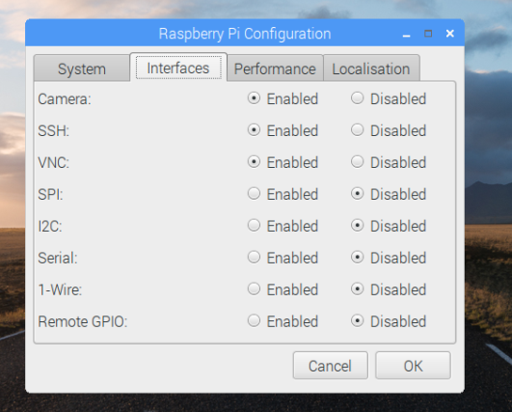

Link for how to connect your camera to Raspberry Pi:

<https://www.raspberrypi.org/learning/getting-started-with-picamera/worksheet/>

1. **Install VLC Player** to Raspberry Pi: run “sudo apt-get install vlc” in terminal
2. First, Find your Raspberry Pi IP address: on your wireless router or in pi terminal by command: ifconfig

In wlano copy or write down the IP address (white line: inet addr)

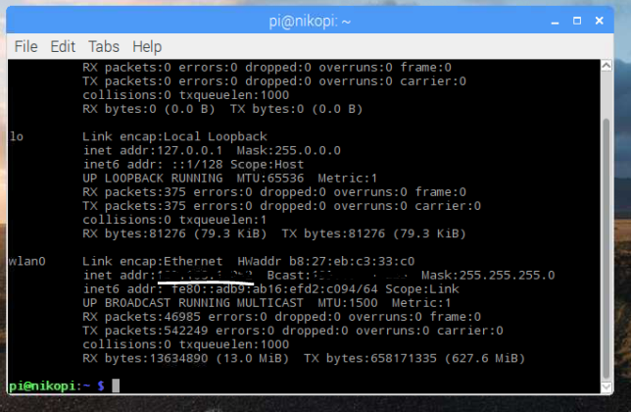

You need your Raspberry pi, IP address for wireless network setting.

**Setup wireless router:**

Login to your wireless router

You can also find your raspberry Pi IP address, in wireless router list



1. Now go to **WAN** on your router:

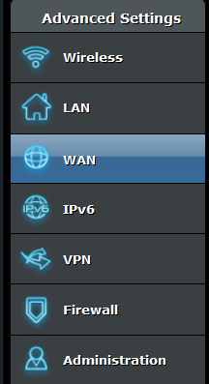

1. Click on **DDNS**: Enable the **DDNS Client** **(Yes)**

Host Name: give a unique name here, XXXXXXX.asuscomm.com (save or write it down because you need it for VLC camera streaming) and Click **Apply**

**We are going to use this ID xxxxx.asuscomm.com for VLC Player streaming**

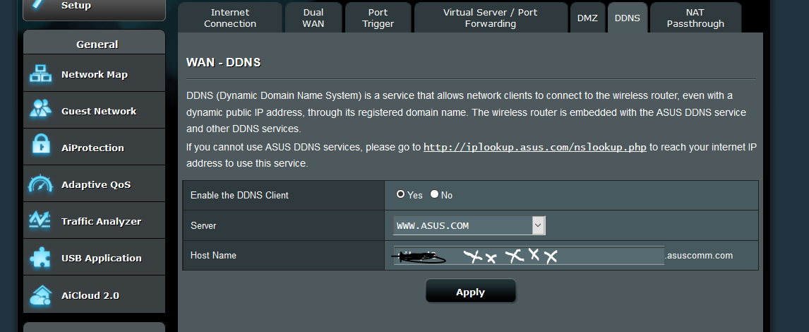

1. **Virtual Server/ port Forwarding**:

Service name: give any name, port range **8554**, your Raspberry Pi **IP address**, Local port **8554**, select Protocol **TCP** and click on add **+**,

Do it same thing for protocol **UDP** and click add + and **Apply**

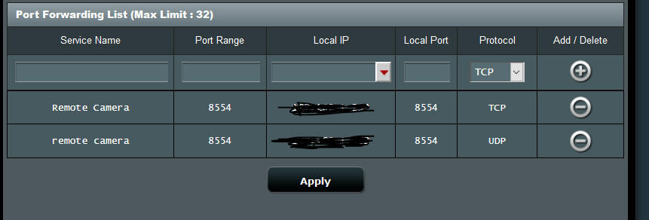

1. Set the **Port Trigger**:

In Description add your Pi **IP address**, **8554**, **TCP**, **8554**, **TCP** and click add **+**, and **apply (In picture below)**

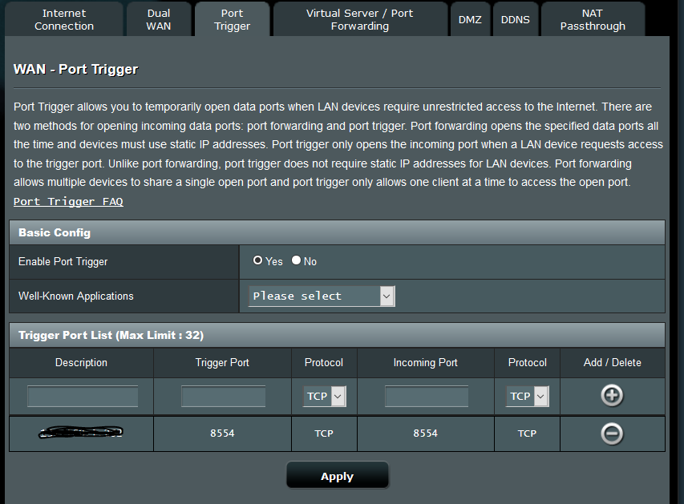

**Done with Wireless Router setup** ☺

**Now go back to Raspberry PI, go to Terminal to run a code:**

1. Enter **Vlc code in to pi terminal**:

raspivid -o - -t 0 -n -w 300 -h 200 -fps 30 | cvlc -vvv stream:///dev/stdin --sout '#rtp{sdp=rtsp://:8554/}' :demux=h264

You can change the **w h, and fps** and **Enter**

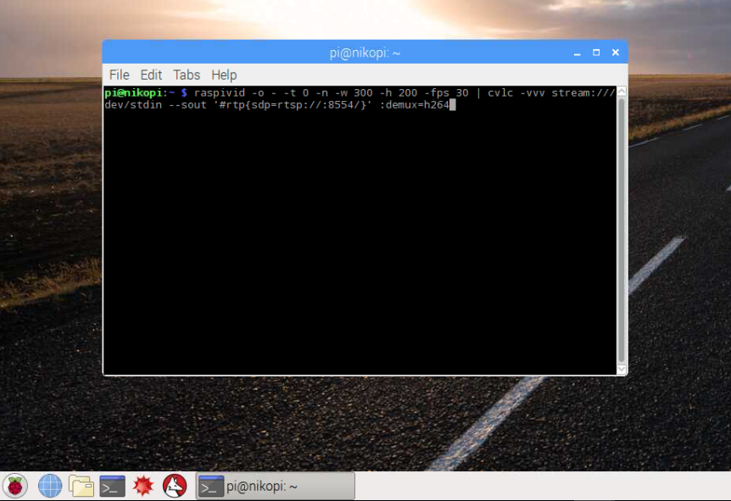

In **step 11** you will see how, Pi terminal will look after code start running.

1. Open **VLC Player** to connect the network: **Media** > **Open Network Stream**

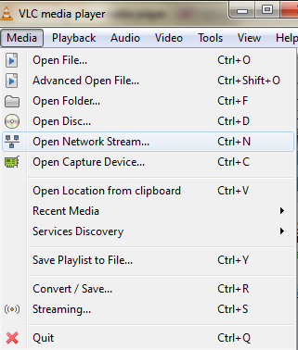

1. Enter: **rtsp://xxxxx.asuscomm.com:8554/**

**That you created in Wireless Router DDNS**

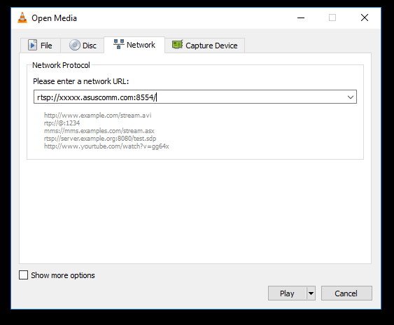

1. **It’s working**: This is how it will look when you run the code in terminal. If you close the terminal than live streaming will stop. So just enter the code and minimize the terminal tap.

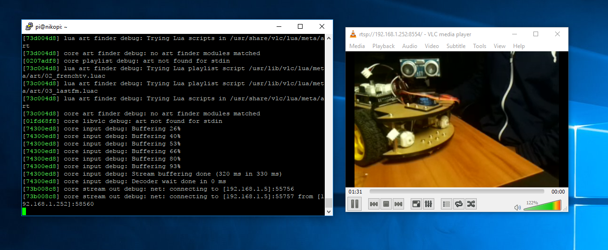

You can use Putty to run the code, but I notice that When I close the putty it also stop the live camera streaming. Use the xxxxx.asuscomm.com for live stream on **any Wi-Fi network** and your phone have to be connect with **any Wi-Fi**. When you connect just wait a little because of delay for few second. I think it will only let one device to live stream at the same time. Currently working on how to live stream on **mobile network**. Currently it’s **not working on mobile** data. I am trying my best to make it easier for everyone. Thank you ☺

For reference: VLC installation and code

<http://www.raspberry-projects.com/pi/pi-hardware/raspberry-pi-camera/streaming-video-using-vlc-player>